# Project title: Rain away

## Group Name: R.A

Member #1 Name: Lim Pei Sheng

Member #1 Admin No.: 164347E

Member #2 Name: Nicholas Poh Jun Heng

Member #2 Admin No.: 164353M

# Introduction

**Rain Away** is a easy to learn casual arcade game. The player plays as a raindrop falling from the sky, trying to get as far as possible towards the ground without getting hit by objects while in the air.

# Target audience

Target Audiences for this game are everyone 5 years old and above.

# Proposed idea

**Rain Away** is a 2D Casual Arcade game where the player play as a raindrop falling from the sky. The player will need to maneuver and avoid obstacles and traps while falling. There will also be powerup which will benefit the player in terms of gameplay and scoring. The game will have a high score system which will record the player’s highest score and rank them against others. The game will also be featured in multiple game mode aside from the normal game mode.

# 

# 

# Game Features

### Game Difficulty:

Easy - Introduces the core mechanics of the game.

* Gates: Each Correct Gate will give the player 1 Star (Maximum of 3/game difficulty)
* Easy Amount and Difficulty of Obstacles

Medium - Introduces more obstacles of the game

* Medium Amount and Difficulty of Obstacles

Hard - 3 Gates with reverse hints with medium amount of obstacles

* Medium Amount and Difficulty of Obstacles
* Increased difficulty on hints of Gate

### Game Modes:

Normal mode - Stars

This mode will feature lesser types of power up than Arcade mode but the player will have 3 lives and will have complete the level they can before their lives runs out.

Player will play under 3 difficulty which they can select and play.

Arcade mode - Points

This mode will be give only 1 life to the player and the objective is to achieve the highest score before the player die.

In this game mode, the difficulty and speed of the game will increase as the player progress further down from the start.

Time attack mode - Time

This mode will have a time limit. The player will need to grab a bonus time powerup which will increase the time of the timer in order to keep playing. The score will be tallied once the player runs out of time.

### Game Design

The Obstacles, trap, power up and gates randomly spawns as the player progress in the level.

Game genre:

2D Casual Arcade game

Main Menu Title Menu Option Menu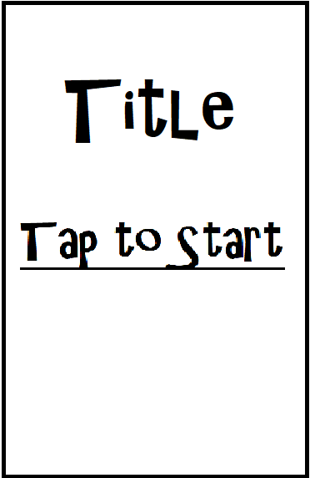

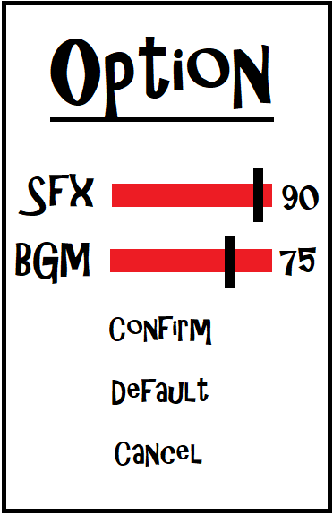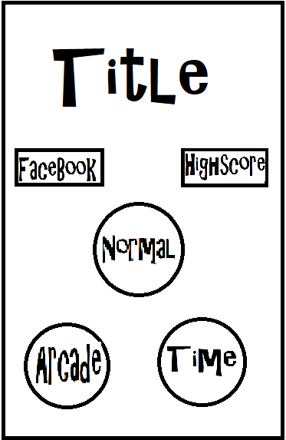

Score Board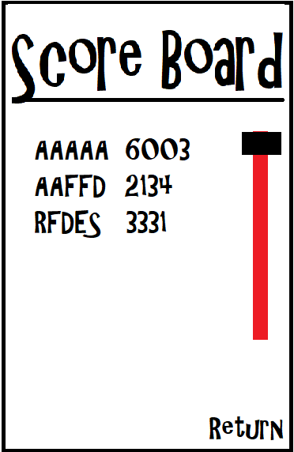

In Game UI:

Touch areas Obstacles & Gate Pause Menu

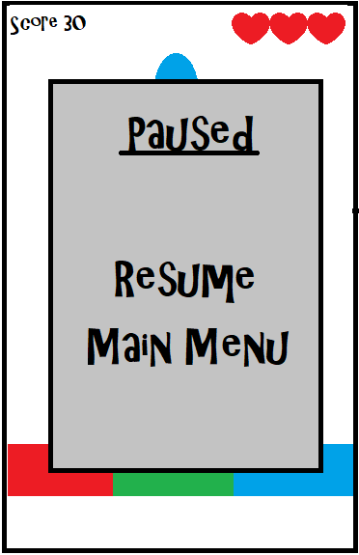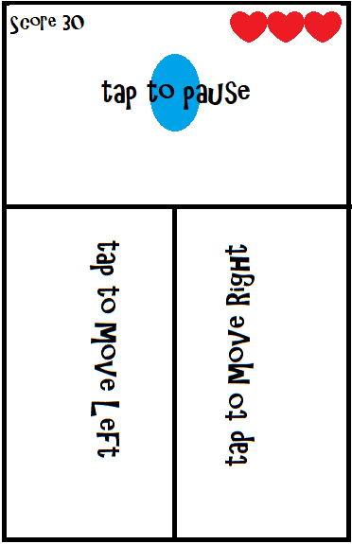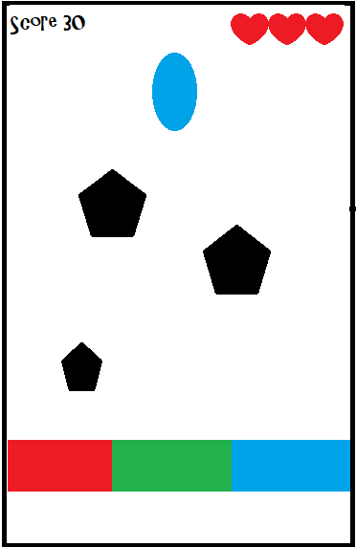

Resume Countdown

# 

# How to play

The Player start off with a random colour and starts falling down in the game. The player then controls the character by touching the sides of the screen or by tilting the phone. The player will be required to avoid obstacles and traps. There will also be powerups where the player can pick up through the game level.

Good to have:

* Items to unlock (through in game money or micro transaction):
* Character skins
* Colors Palette
* Background

# 

# 

# Task Breakdown

|  |  |
| --- | --- |
| Pei Sheng’s Task | Nicholas’s Task |
| Part 1 | |
| Level Generation | Control |
| Fonts | Game mode |
| Scoring | **Menu Screen** |
| Game Objects | **Audio** |
| Sprite animation | **Scene manager**  **-Buttons** |
| Restart game | Collision |
| Part 2 | |
| Pause | Accelerometer |
| Leaderboard | Vibration |
| Character sprites | UI Feedback |
| Background image | Social Media |
| Gameobject sprite |  |

**Power Up & Traps**

|  |  |  |  |  |
| --- | --- | --- | --- | --- |
| **Name** | **Description** | **Effect** | **Duration(s)** | **Chance for Obstacles to appear** |
| Arcade | | | | |
| Shroud | Gain Invisibility for a period of time | Can go through objects | 5 |  |
| Score Multiplier | Increase points/gain | Increase Multiplier by 1x | - | The lower the multiplier the higher chance, min 30% max 80% |
| Slow Time | Slow down time in game | Slow down time by (half) | 10 |  |
| Time Attack | | | | |
| Increase Time | Increase time for Time Attack | Increase Time Limit by 10s | - |  |
| Time Freeze | Stops Timer for awhile | Timer freezes | 5 | Lower the chance the further the player progresses  Min: 10%, Max: 30% |
| Slow Down | Slow down player | Slow down player speed | 5 | 1.Player further than <certain> meters  2.Chance increase every <certain> meter |